Purpose
The purpose of this Standard Operating Procedure (SOP) is to define the Kentucky-specific operational workflows and processes required for compliant Utilization Review (UR) activities performed by Point C in accordance with KRS 304.17A-600 through 304.17A-619, 29 CFR 2560.503-1, and the Kentucky Department of Insurance Utilization Review Registration Application requirements.
This SOP implements the requirements identified under HIPMC-UR-1 Section 6(a–e) and must be included in the organization’s Kentucky UR Registration submission.

Scope
This SOP applies to all Kentucky UR activities performed by Point C, including:
- Pre-Authorization
- Pre-Admission Authorization
- Concurrent (Continued Stay) Review
- Retrospective Review
It also covers:
- Clinical criteria use
- Special circumstance handling
- Client listing (KY-required)
- Certification requirements

- DEFINITIONS
Utilization Review (UR): Evaluation of medical necessity, appropriateness, or efficiency of health care services.
Necessary Information: Limited to (a) face-to-face evaluations, (b) second opinions, and (c) other information identified by the Department as essential to a UR decision.
Urgent Review: Request where delay may jeopardize life, health, or function.
Concurrent Review: Review of ongoing inpatient care or emergency admissions where the patient remains hospitalized.

- ROLES AND RESPONSIBILITIES
4.1 Registered Nurse (RN) Reviewer
- Conducts preliminary clinical review.
- Applies criteria and identifies need for physician review.
4.2 Physician Reviewer (KY-Required Specialty Match)
- Must be licensed and of same or similar specialty as ordering provider for adverse determinations (KRS 304.17A-607(1)(b)).
- Renders medical necessity denials.
4.3 Chiropractor/Optometrist Reviewer
- Required for denials of respective services (KY mandate).
4.4 UR Staff
- Maintain accessibility 40 hours/week and extended hours on Mon/Fri until 6 p.m. including federal holidays (KRS 304.17A-607).
- Ensure timely notice issuance.

- STANDARDIZED UR WORKFLOWS (6(a))
5.1 Pre-Authorization SOP
5.1.1 Workflow Steps
- Request Intake
  - Received via toll-free phone, fax, portal, or EDI.
  - All intake channels must comply with Kentucky accessibility requirements.
- Urgency Determination
  - Determine if delay jeopardizes health/function → treat as urgent.
  - Otherwise → standard pre-service.
- Clinical Review
  - RN applies approved criteria.
  - If criteria not clearly met → escalate to physician of same/similar specialty (required).
- Decision Timeframes
  - Urgent: Within 24 hours of receiving necessary information (KRS 304.17A-607(1)(i)1).
  - Standard: Within 5 days of receiving necessary information (KRS 304.17A-607(1)(i)2).
- Notification
Written notice with authorization or denial elements
Denial Written notice must include:
  - Medical/scientific reasons
  - Reviewer’s license number & state
  - Alternatives (if applicable)
  - Appeal rights
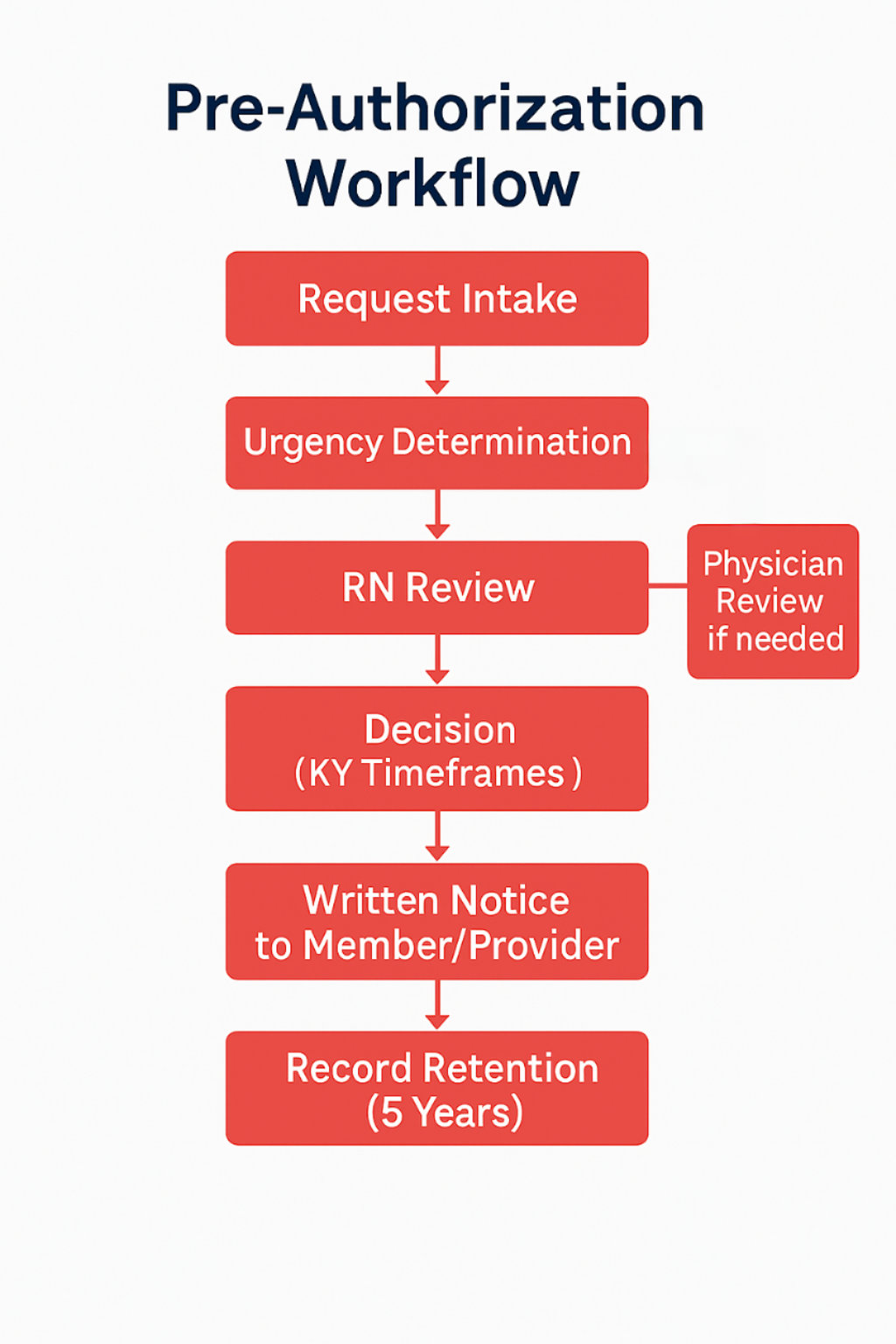

5.2 Pre-Admission Authorization SOP
5.2.1 Workflow Steps
- Request Intake for hospital admission or outpatient surgery.
- Automatic Urgent Classification
  - All pre-admission/outpatient surgery requests must be processed as urgent per KRS 304.17A-600(16)(b).
- Clinical Review
    - RN applies approved criteria.
    - If criteria not clearly met → escalate to physician of same/similar specialty (required).
- Decision timeframes
  - Must be completed within 24 hours of obtaining necessary information.
- Notification Written notice with authorization or denial elements.
Denial written notice must include:
    - Medical/scientific reasons
    - Reviewer’s license number & state
    - Alternatives (if applicable)
    - Appeal rights
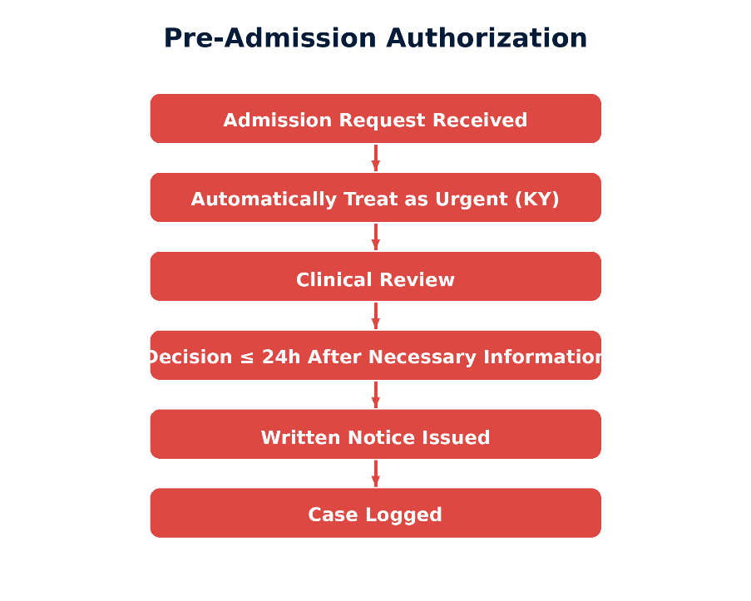
5.3 Concurrent Review SOP
5.3.1 Workflow Steps
- Trigger:
  - Ongoing inpatient stay OR emergency admission retrospective review while patient still hospitalized.
  - All considered concurrent per Kentucky.
- Urgent Review Requirement
  - Must be handled as urgent.
- Clinical Review
    - RN applies approved criteria.
    - If criteria not clearly met → escalate to physician of same/similar specialty (required).
- Decision Timeframe
  - Within 24 hours of receiving necessary information.
  - Failure to meet timeframe = deemed authorization (KRS 304.17A-607(2)).
- Notice
  - Issued before expiration of previously authorized days
    - Notices must go to member/authorized person, and provider.

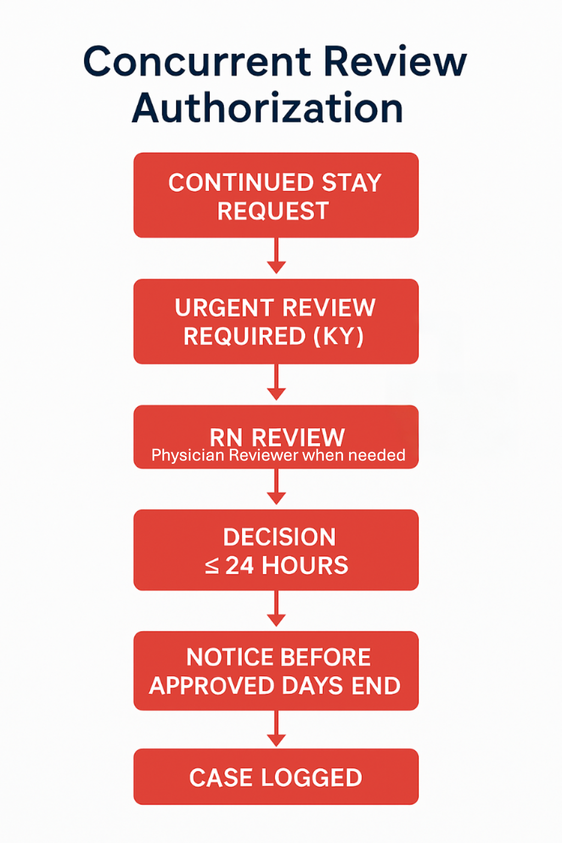

5.4 Retrospective Review SOP
5.4.1 Workflow Steps
- Intake of Request
  - Submitted after services rendered
- Clinical Review
- RN applies approved criteria.
- If criteria not clearly met → escalate to physician of same/similar specialty (required
- Decision Timeframe
  - Within 5 days of obtaining necessary information (KRS 304.17A-607(1)(i)2).
- Retrospective Denial Restrictions
  - Cannot rescind prior approval unless fraud/misrepresentation (KRS 304.17A-611).
- Notification Requirements
    - Send to member and provider

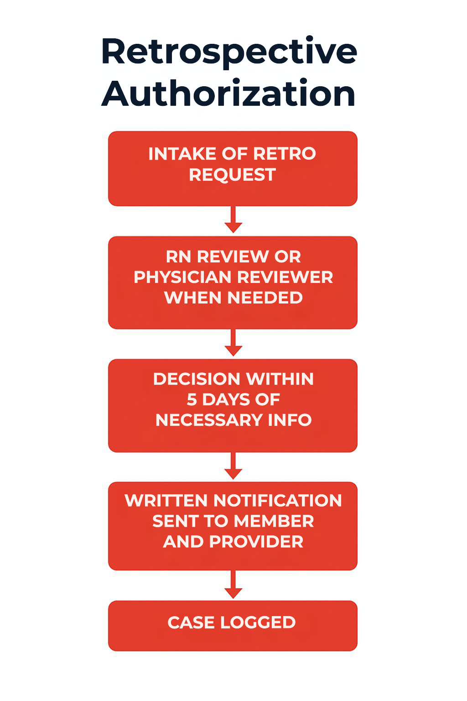

- CLINICAL CRITERIA USE

Point C uses nationally recognized criteria MCG, and plan specific clinical guidelines.
Kentucky-required elements:
- RN reviewers applying standard criteria for screening
- Only same-or-similar-specialty physicians may make adverse determinations (KRS 304.17A-607(1)(b)).
- Chiropractor/optometrist denials must be issued by KY-licensed reviewers of those specialties.
- Criteria applied uniformly and documented on every case.
- Peer-to-peer discussion opportunity offered before adverse determination.
- Documentation of each criteria applied and rationale for denials
- Annual review and approval of criteria by Quality Management Committee and Medical Director.

- SPECIAL CIRCUMSTANCES WORKFLOW STANDARDS
Kentucky requires additional standards for:
1. Urgent Situations
- Must issue decision within 24 hours after necessary information.
2. Non-Contact Denial Protections
Providers attempting contact during normal business hours:
- If insurer fails to respond despite 3 attempts in 4 hours, insurer must cover until decision is made (KRS 304.17A-615).
3. Emergency Admission While Hospitalized
Any retrospective review request while patient remains hospitalized is treated as concurrent review (urgent).
4. Accessibility SOP Requirements
- Toll-free line required and staffed 40 hours/week.
- Must be available through 6 p.m. Monday & Friday including federal holidays (KY-specific).

- Policy History
Policy Number | Author | Description of Change & Reason | Approval Date | Distribution Date
OP 1.0 | On File | Initial SOP Drafted | 1/30/2026

